**LAB PROGRAM 3(SUPPLIERS DATABASE)**

**QUERIES**

create database supplier;

use supplier;

/*SUPPLIERS(sid: integer, sname: string, address: string)

PARTS(pid: integer, pname: string, color: string)

CATALOG(sid: integer, pid: integer, cost: real)*/

create table SUPPLIERS(sid integer,sname varchar(20),address varchar(40),primary key(sid));

insert into SUPPLIERS values(10001,'Acme widget','Banglore');

insert into SUPPLIERS values(10002,'Johns','Kolkata');

insert into SUPPLIERS values(10003,'Vimal','Mumbai');

insert into SUPPLIERS values(10004, 'Reliance','Delhi');

commit;

select* from SUPPLIERS;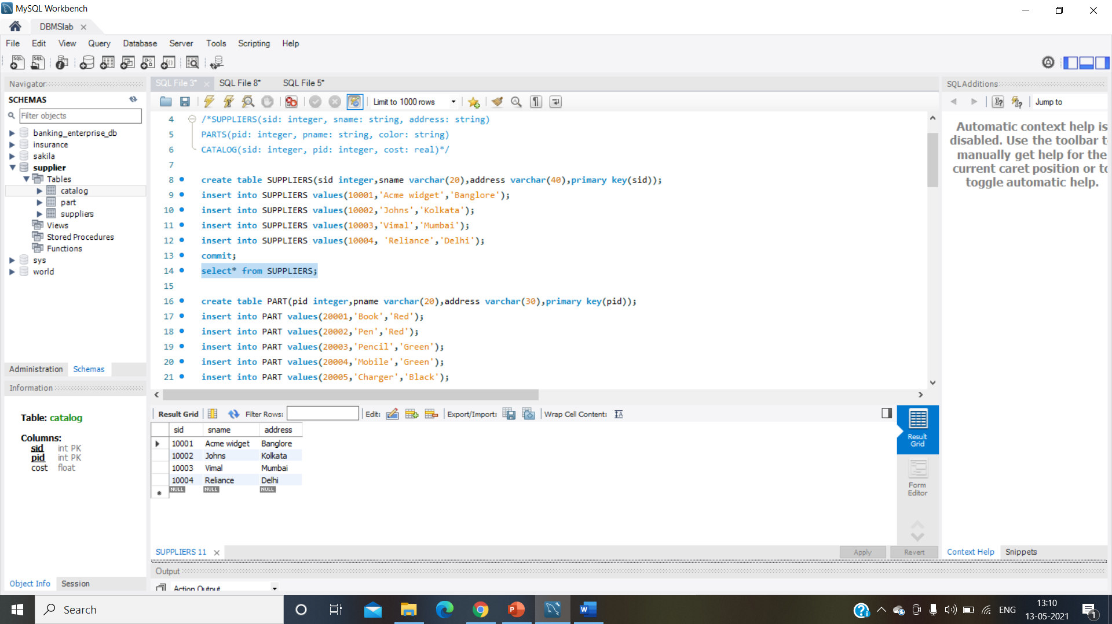

create table PART(pid integer,pname varchar(20),address varchar(30),primary key(pid));

insert into PART values(20001,'Book','Red');

insert into PART values(20002,'Pen','Red');

insert into PART values(20003,'Pencil','Green');

insert into PART values(20004,'Mobile','Green');

insert into PART values(20005,'Charger','Black');

commit;

select* from PART;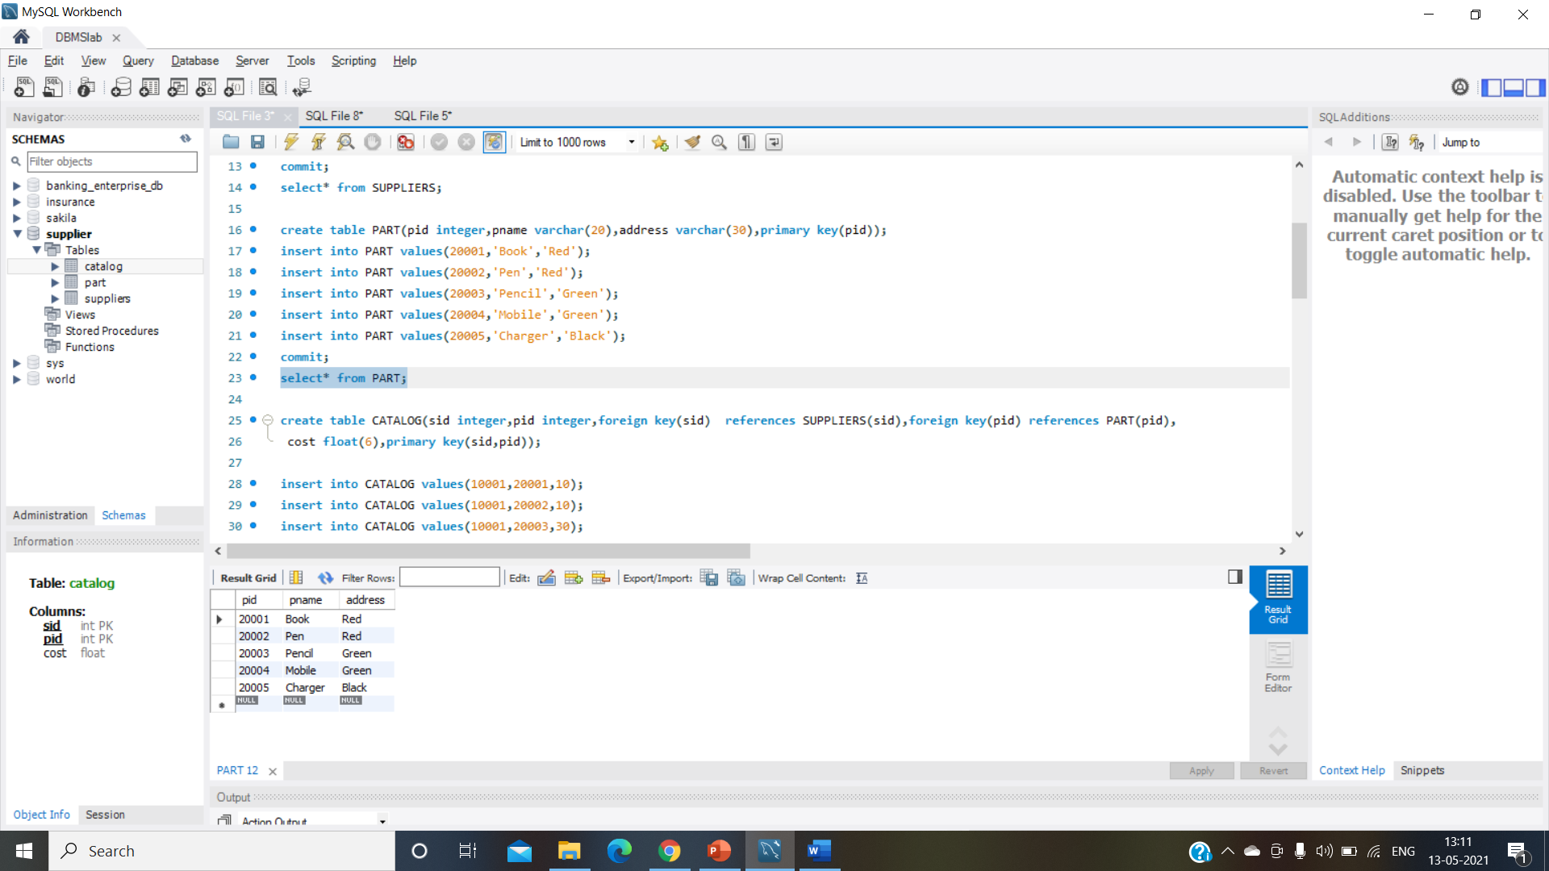

create table CATALOG(sid integer,pid integer,foreign key(sid) references SUPPLIERS(sid),foreign key(pid) references PART(pid),

cost float(6),primary key(sid,pid));

insert into CATALOG values(10001,20001,10);

insert into CATALOG values(10001,20002,10);

insert into CATALOG values(10001,20003,30);

insert into CATALOG values(10001,20004,10);

insert into CATALOG values(10001,20005,10);

insert into CATALOG values(10002,20001,10);

insert into CATALOG values(10002,20002,20);

insert into CATALOG values(10003,20003,30);

insert into CATALOG values(10004,20003,40);

commit;

select* from CATALOG;

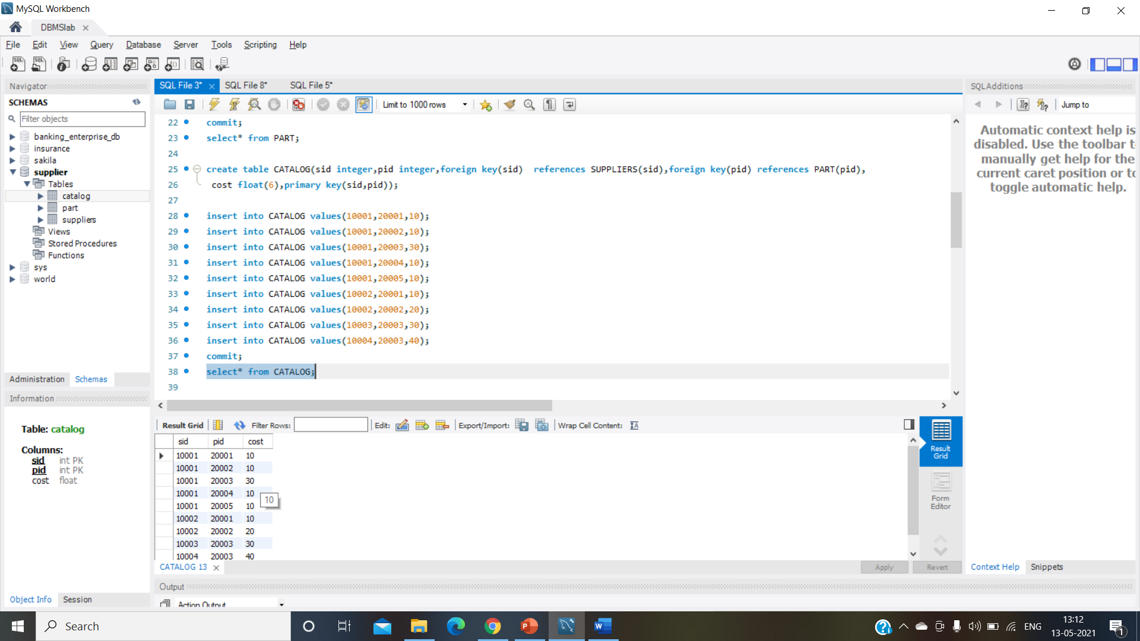

/*i) Find the pnames of parts for which there is some supplier.*/

SELECT DISTINCT P.pname

FROM Part P, Catalog C

WHERE P.pid = C.pid;

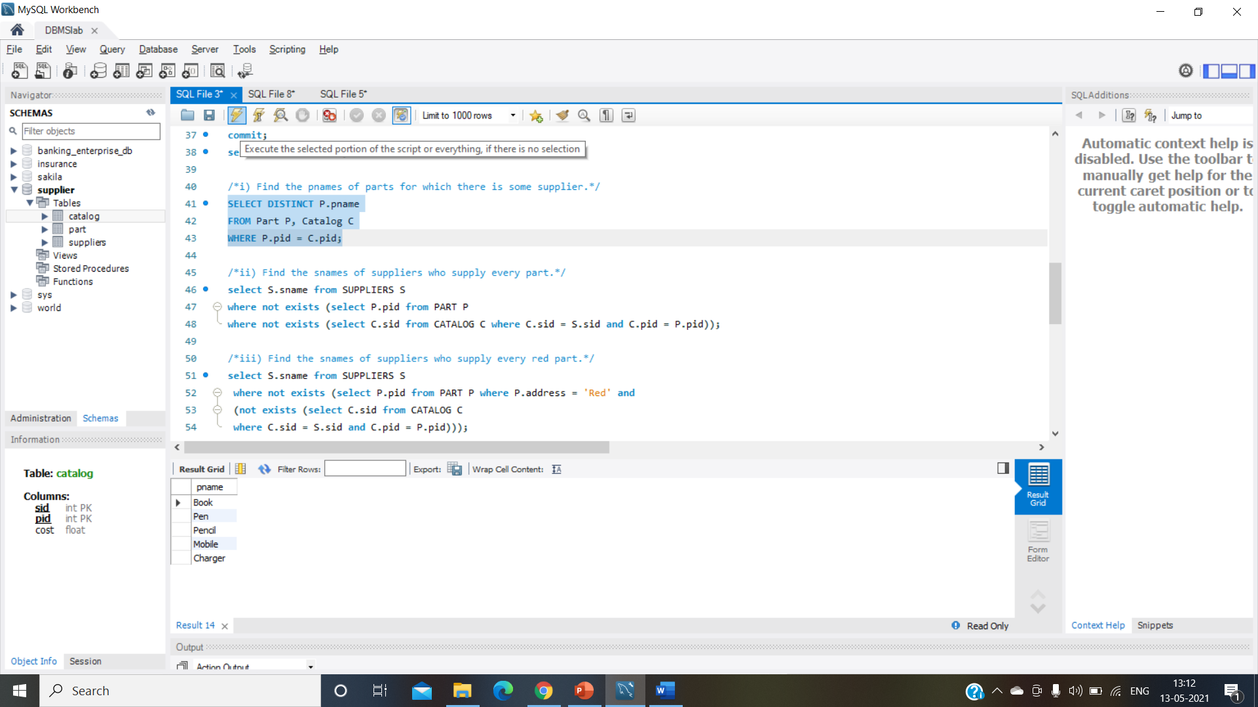

/*ii) Find the snames of suppliers who supply every part.*/

select S.sname from SUPPLIERS S

where not exists (select P.pid from PART P

where not exists (select C.sid from CATALOG C where C.sid = S.sid and C.pid = P.pid));

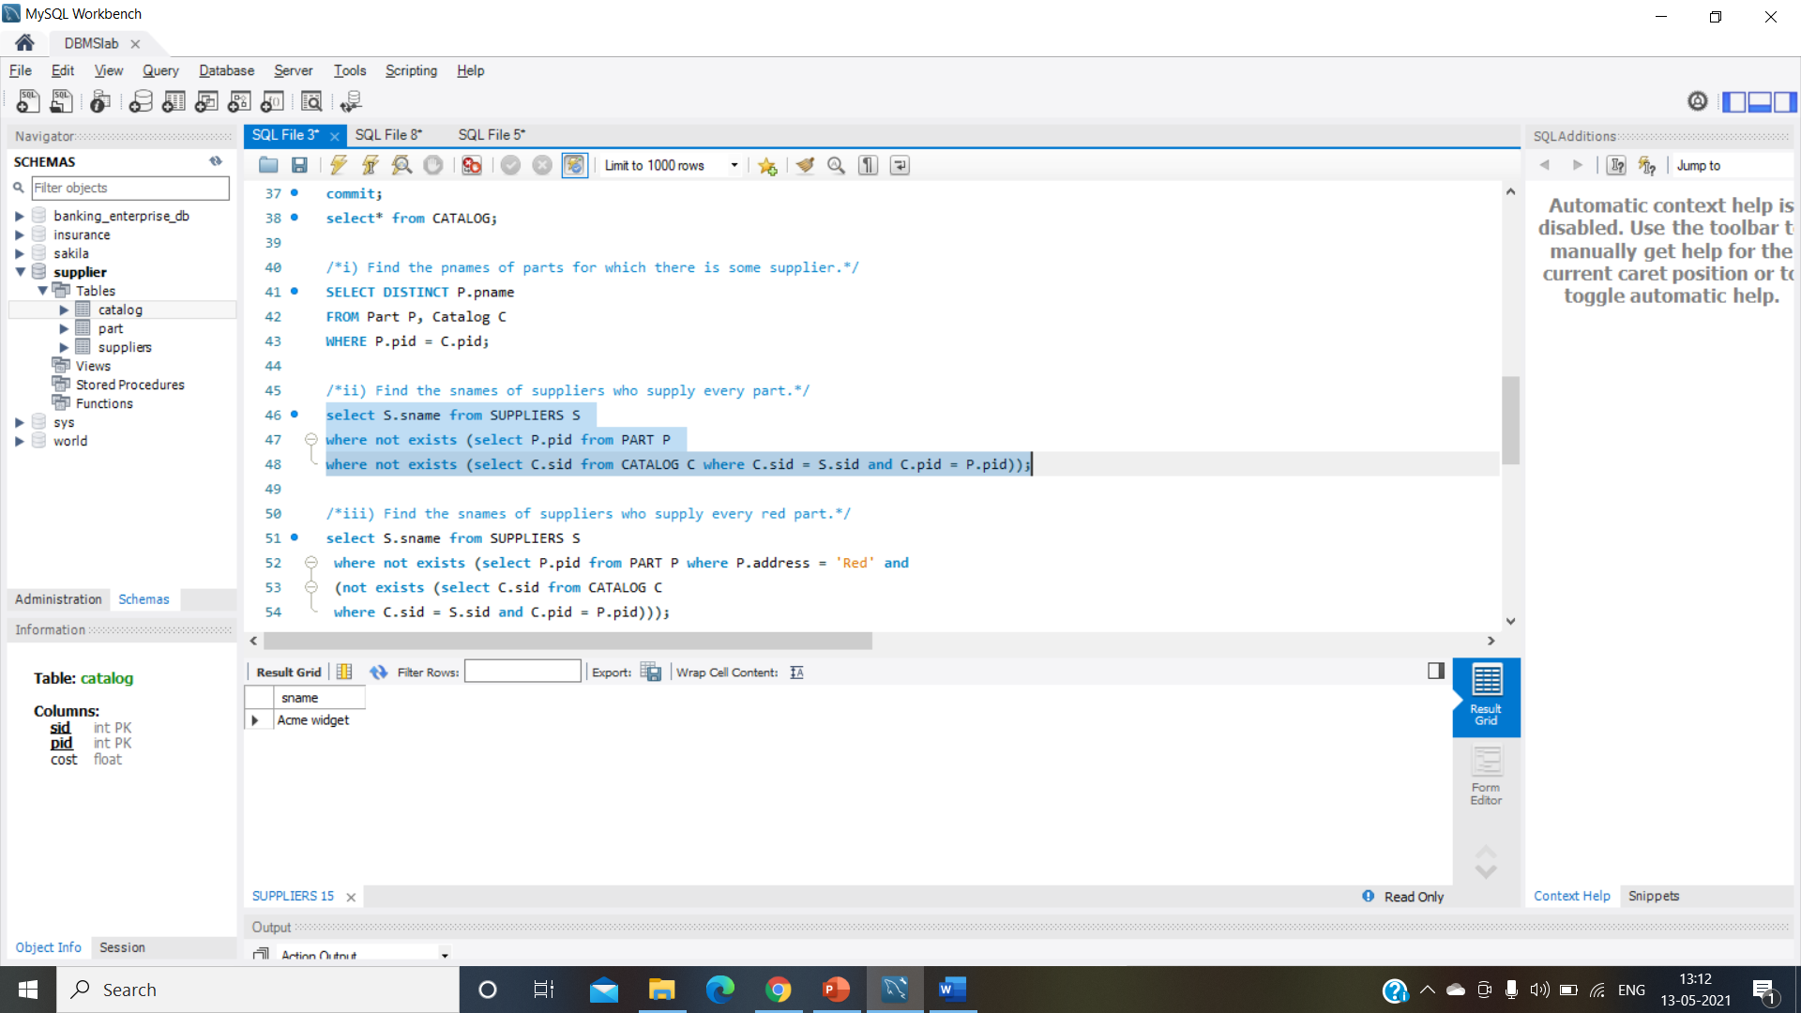

/*iii) Find the snames of suppliers who supply every red part.*/

select S.sname from SUPPLIERS S

where not exists (select P.pid from PART P where P.address = 'Red' and

(not exists (select C.sid from CATALOG C

where C.sid = S.sid and C.pid = P.pid)));

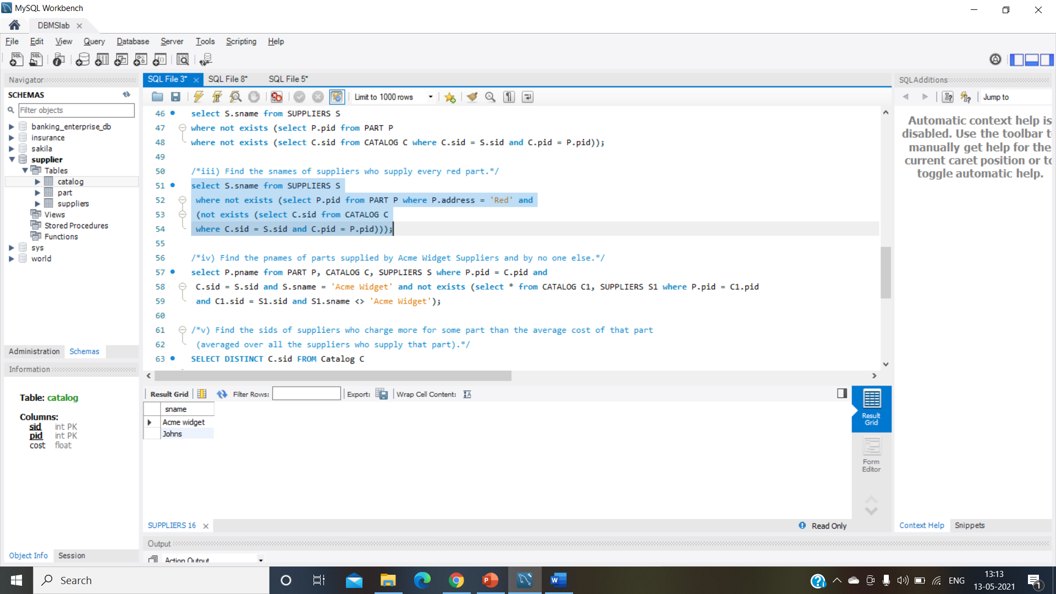

/*iv) Find the pnames of parts supplied by Acme Widget Suppliers and by no one else.*/

select P.pname from PART P, CATALOG C, SUPPLIERS S where P.pid = C.pid and

C.sid = S.sid and S.sname = 'Acme Widget' and not exists (select * from CATALOG C1, SUPPLIERS S1 where P.pid = C1.pid

and C1.sid = S1.sid and S1.sname <> 'Acme Widget');

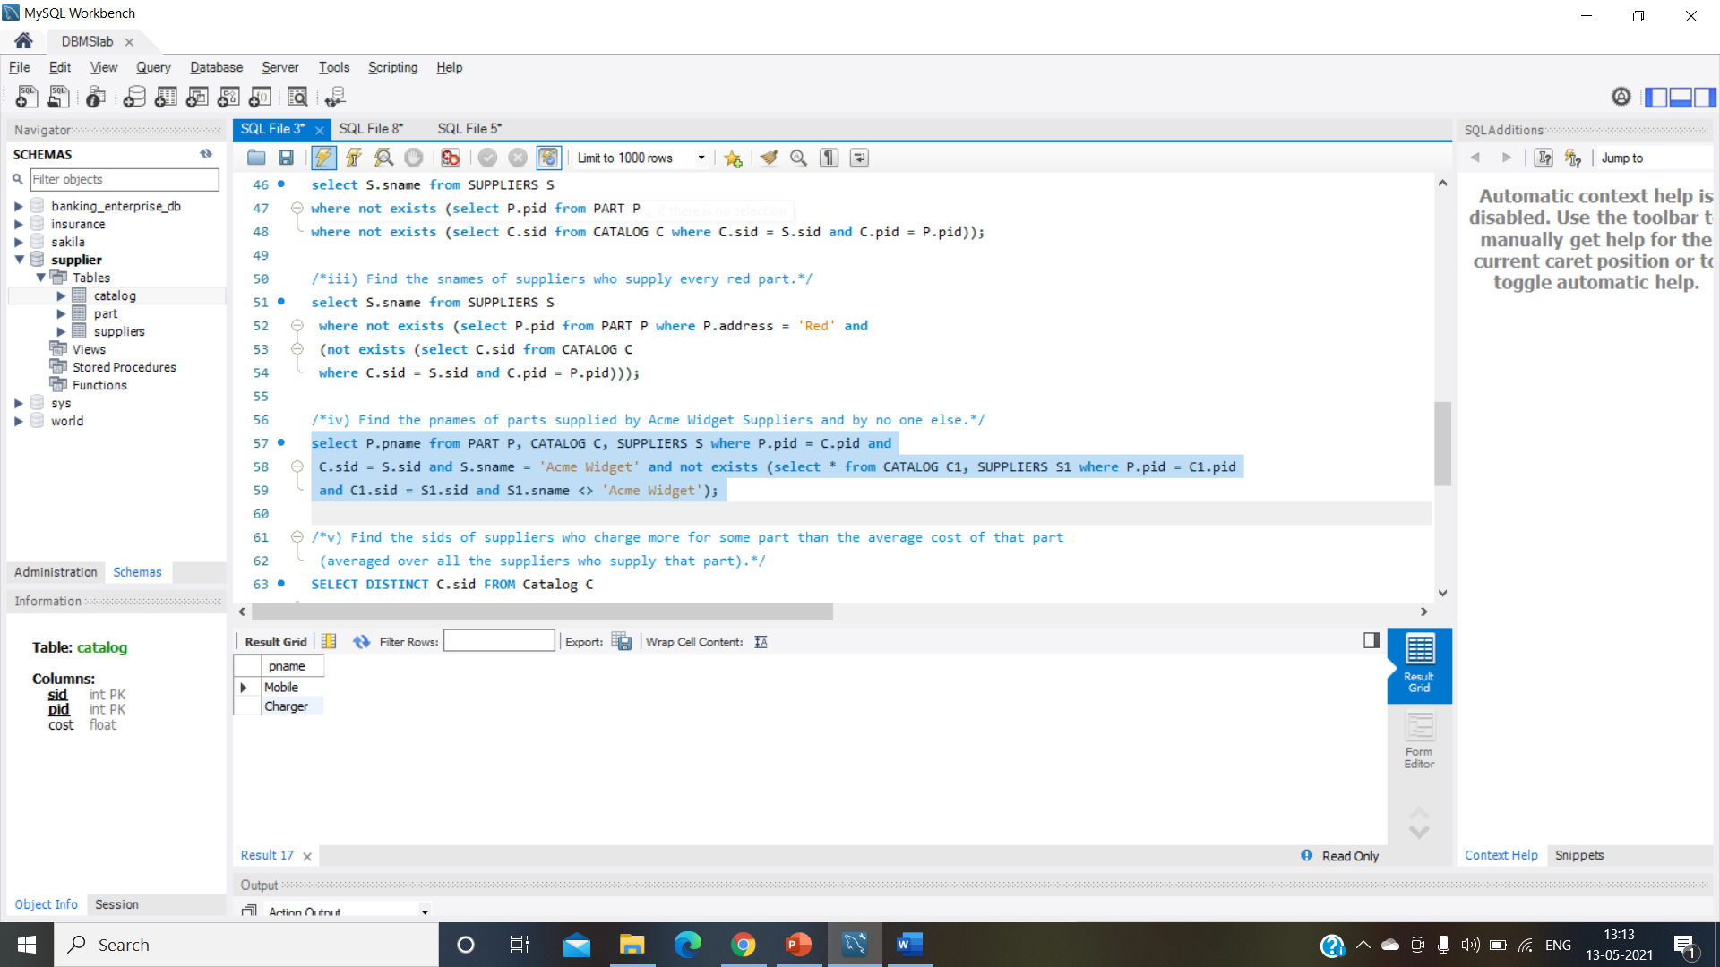

/*v) Find the sids of suppliers who charge more for some part than the average cost of that part

(averaged over all the suppliers who supply that part).*/

SELECT DISTINCT C.sid FROM Catalog C

WHERE C.cost > ( SELECT AVG (C1.cost)

FROM Catalog C1

WHERE C1.pid = C.pid );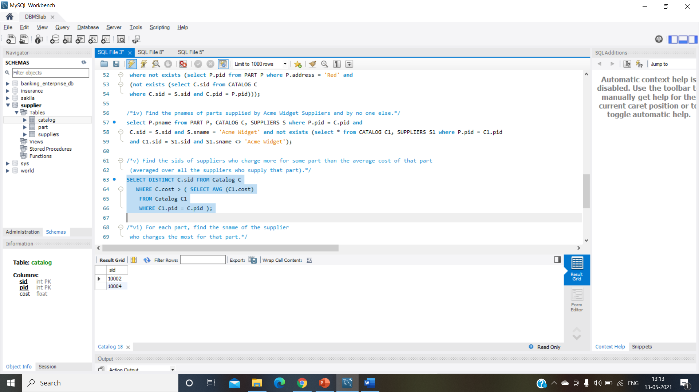

/*vi) For each part, find the sname of the supplier

who charges the most for that part.*/

SELECT P.pid, S.sname

FROM Part P, Suppliers S, Catalog C

WHERE C.pid = P.pid

AND C.sid = S.sid

AND C.cost = (SELECT MAX(C1.cost)

FROM Catalog C1

WHERE C1.pid = P.pid);